**Book Shop management system**

**Date: 12/12/2022**

**Reviewed by:**

|  |  |  |
| --- | --- | --- |
| **SL no** | **Name Of The Scholar** | **Working On** |
| 1 | Nishu | registration module |
| 2 | Preeti | Login module |
| 3 | Abhinaya | Search module |
| 4 | Parikshith | Add to cart module |
| 5 | Vijay | Payment module |
| 6 | Ashika | Logout module |

**Aim / Objectives:**

This project is based on Book Shop Management where customer should register by using by their mobile number, the user can login by using username and password. User can order from online menu and can enable device location to ensure accurate address and faster delivery. The user should pay by using Credit &Debit cards, Cash on delivery.  
 Now the functionalities are limited but over a period of time we will add new functionalities to improve the user experience. The purpose of this to create a clear communication within the team members and others as well.   
 The testing will identify fix and retest all the defects of the application including high and, medium, low severity and prioritize the defects.

**Description:**

1. **Registration module**- The user should register through their mobile number (Numeric characters with 10 digits) and by giving name (Alphabetic characters with maximum 20 characters) and Address (Alphanumeric /special characters with maximum 100 characters)
2. **Login module-**The user should be able to login through username (Only alphabetic characters with minimum 5 and maximum20 characters) and password (Only alphanumeric and special characters of 8 to 16 characters)
3. **Search Module**- User should be able to search the book (alphanumeric characters) and Authors name (only alphabetic characters)
4. **Add to cart-** User can store the favorite items to the cart (maximum 50 items)
5. **Payment module-** User can buy the product by cash on delivery (by giving valid address). User should be able to buy their products by entering their credit & Debit cards numbers (only 16 numeric values).
6. **Logout-** User can be able to logout by clicking logout.

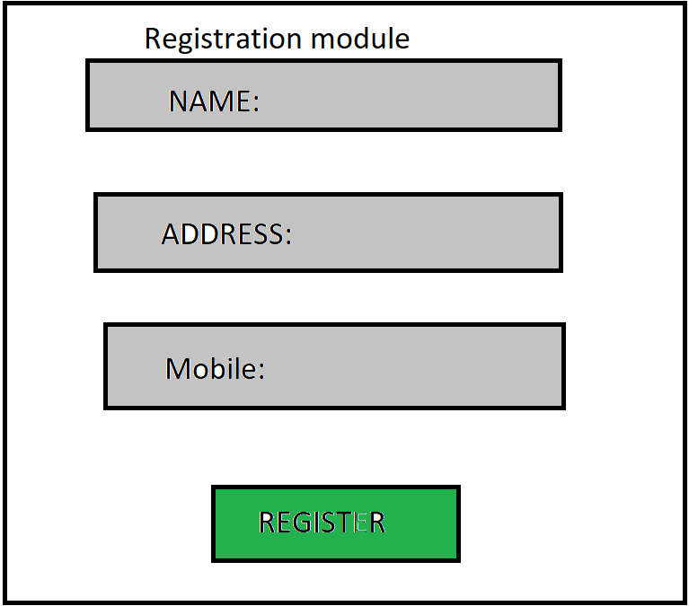

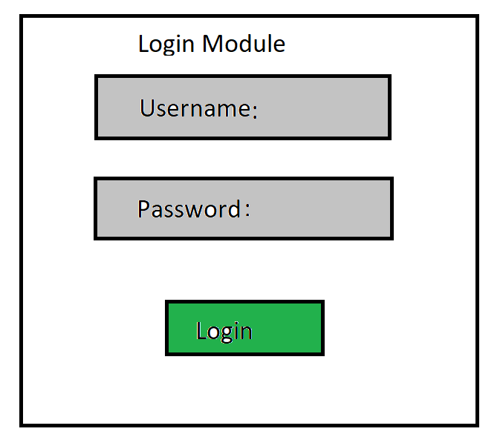

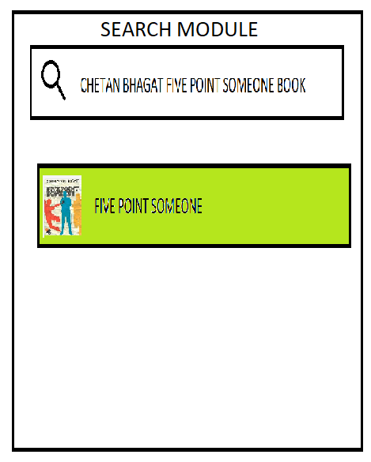

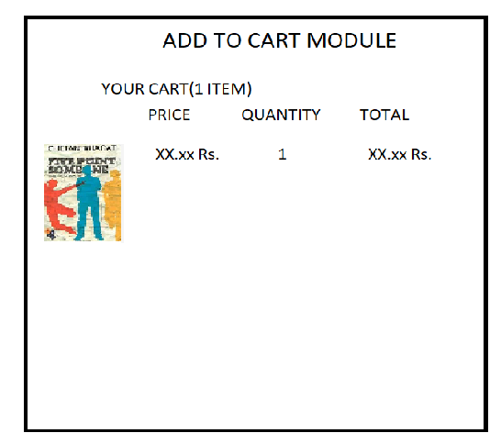

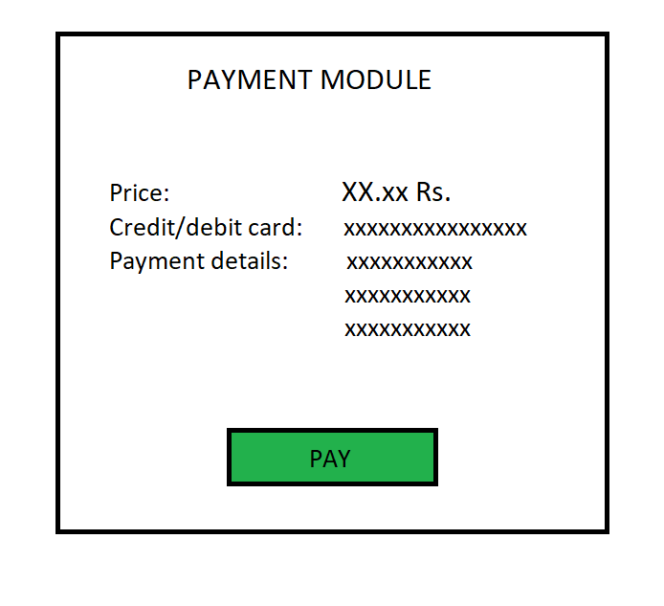

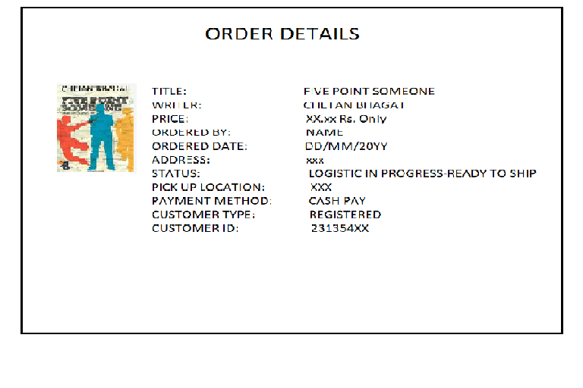

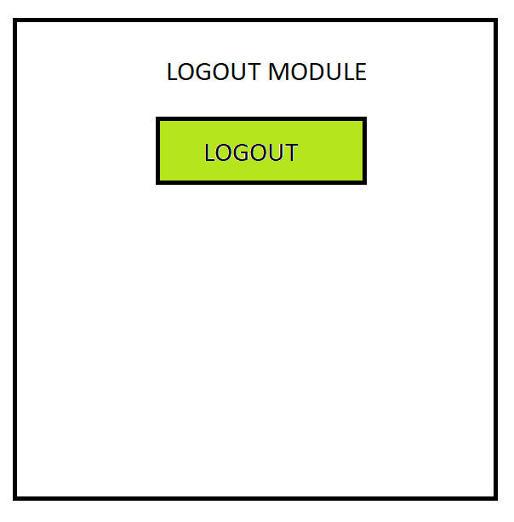

### Tools to be used

1. Use any IDE to develop the project. It may be Eclipse /My eclipse
2. Oracle for the database.

**Front End and Back End**

1. **Front End:** Eclipse
2. **Back End:** Oracle